KINNERLEY ANNUAL PARISH MEETING

Monday 23rd March 2020
Kinnerley Parish Hall at 7.00 pm

TO: - All Town Council Members, the Public and the Press

A PUBLIC MEETING FOR MEMBERS OF THE LOCAL ELECTORATE

Chaired by Cllr. N Barclay - Chairman of Kinnerley Parish Council

The Parish Meeting is an opportunity for local people on the Electoral Roll for Kinnerley Parish to raise any matters of concern to them that relate to their local community.

AGENDA

- Welcome and Introduction from the Chairman of the Parish Council
- Apologies for absence
- Approve the minutes of the Annual Parish Meeting held on Monday 25th March 2019.
- Annual Report from Chairman on Previous Years’ Activity
- Annual Report from Cllr Matt Lee – Shropshire Council
- To receive any matters of interest or concern to the Parish of Kinnerley from the electors of the Parish.
- To approve the date of the next Annual Parish Meeting scheduled for 22nd March 2021

Please Note:
All Parish Electors are invited to attend and take part in this meeting. Given the current situation with Coronavirus, you may prefer instead to raise your question or issue with the Parish Clerk by e-mail at kinnerleyparishcouncil@gmail.com.

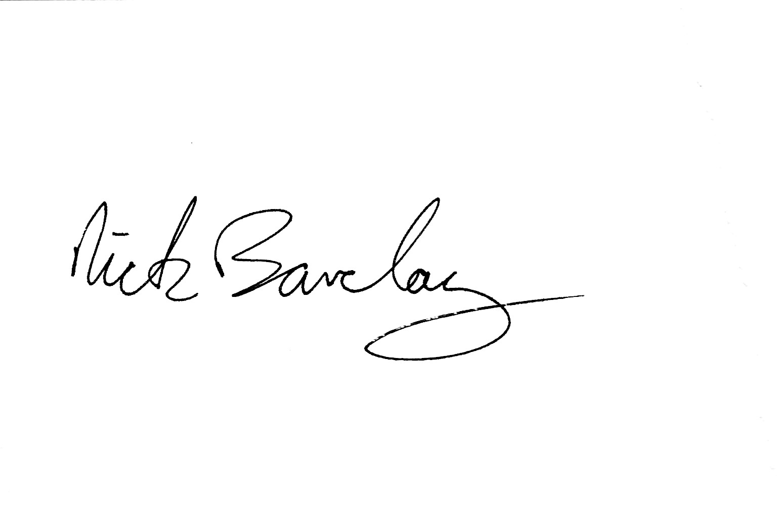
Cllr Nick Barclay
Chairman
16th March 2020

Clerk: Marian Giles, c/o 61 Willow Street, Oswestry, SY11 1AQ
Tel: 01691 679171 Email: kinnerleyparishcouncil@gmail.com

